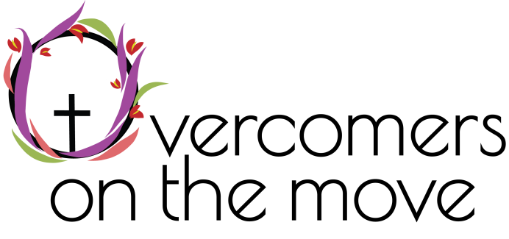

Overcomers on the Move is proud to host the 1st Annual Overcomers Run/Walk 4 Recovery (Batelle Darby Metro Park, 1775 Darby Creek Drive, Galloway, OH 43119) on Saturday, September 23, 2023! All profits and donations from the event will go to Overcomers on the Move. All Sponsorships need to be received by ___9/1/2023_______ to be included on the race shirt.

Overcomers Run/Walk 4 Recovery is to promote peer support and celebrate National Recovery Month. WE DO RECOVER & OVERCOME!

We thank all our sponsors and attendees in advance.

Sponsorship Options:

NOTE: All sponsorship options include:
- Host a table.
- Your company Logo on registration page
- Special announcements mentioning sponsor name before and after the race.

Diamond - $1,000
- PROMINENT display of logo/name on the BACK of race T-shirts
- 6 complimentary race entries and 6 complimentary race T-shirt

Platinum - $500
- Logo/name on the back of the race T-shirt
- 4 complimentary race entries and 4 complimentary race t-shirts

Gold - $250
- Logo/name on the back of the race T-shirt
- 2 complimentary race entries and 2 complimentary race t-shirts

Silver - $100
- Name on the back of the race T-shirt

COMPANY NAME: | ADDRESS:
CONTACT PERSON: | CONTACT NUMBER:
TITLE: | SPONSORSHIP LEVEL:
CONTACT EMAIL: | SIGNATURE:

https://www.overcomersonthemove.org/events/race

All sponsors will be contacted prior to the race for pertinent information.

“And they overcame him by the blood of the Lamb and by the word of their testimony, and they did not love their lives to the death.” Revelation 12:11 NKJV

